EECS 581- Team 05: Project Proposal Report
Date: 23 October 2017

Team Name- JAARC JAARC I’M A SHARK

Team Members-
- Richard Aviles r556a812@ku.edu
- Colby Hughes c578h019@ku.edu
- Ashli Mosiman a663m213@ku.edu
- James Muoghalu j286m692@ku.edu
- Alex Pechin a800p737@ku.edu

Team Meeting Time- Tuesdays, 2:30pm
Lab Meeting Time- Varies

Contact- Colby Hughes
Project Sponsor (if any)- None

Project Description-
- We plan on making an Android application that will allow users to create errands and events. A person using the app will be able to select specific locations and assign a list of reminders for them, and the reminders will pop up when the user is in the vicinity of those particular locations. For example, the app can pull up a shopping list when the user is travelling in the vicinity of a certain grocery store, and if the user is near a school building, the app can pull up a class schedule for that day. Opening the app will allow users to store other reminders and notes as they pertain to specific errands as well as update the tasks as they are completed. There will also be a social aspect to the project. App users will be able to post notes and reminders for other people by requesting that those people add them a contacts/friends list. Those new contacts will then verify that they know the person sending the request, allowing them both to interact with each other inside the app.
- A completed version of this application will allow the user to keep track of all of their responsibilities as well as those of their friends, family members, etc. This project is intended to surpass the limitations of basic Calendar and Notes applications by providing a visual and interactive environment in which smartphone users can play their daily tasks.

Project Milestones-

- First Semester
  - Research (September - October)
    - Java and Android Studio
    - Google Maps API
  - Complete Basic Application Design (i.e. visualization of app) (November)
    - Application Workflow
    - Basic UI Design
  - Base App Functionality (November - December)
    - Basic Google API Integration
    - Basic Ability to Assign Desired Locations via Google Maps
    - Basic Ability to Assign List of Errands / Tasks to Locations
- Second Semester
  - Location Tracking and Notifications (January - March)
    - Location Tracking on an Android Device
    - Detecting Proximity to Set Locations
    - Notifications of Errands for Set Locations
  - Debugging and Testing App (April - May)
    - Testing for Set Locations in Lawrence
  - Polishing (May)
    - Continuation of Bug Fixes
    - Refining UI and App Navigation
    - Tuning User Input and App Functionality

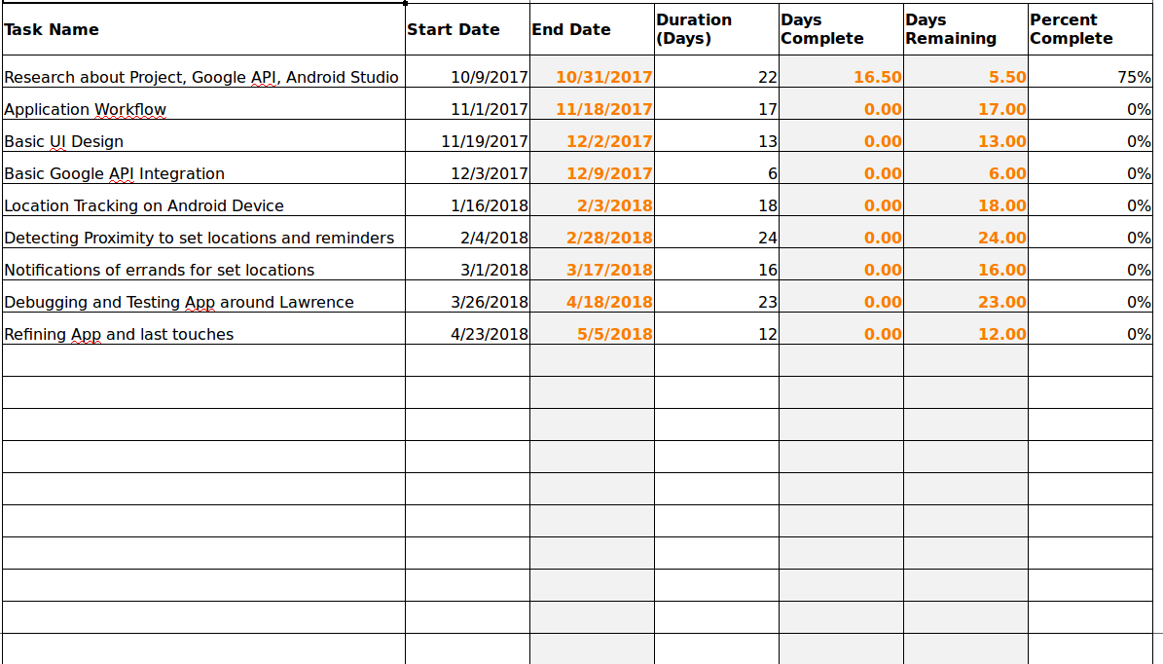

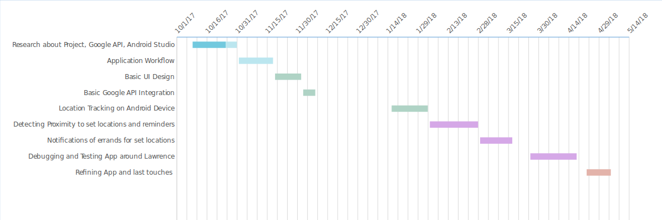

Project Budget-

Resources | Time Needed
Android Studio development tool used to create app | Once we start coding and start research (October)
Google Maps API for getting user location data while using the app | Once we start adding locations to tasks (January)
Android phone used for testing app | Once we start testing the app for functionality and bugs (April)
Database for Events and User Accounts | Research and choosing options (December)

- Overall, the necessary resources will have no cost, considering they are free to use or we have some already at our disposal. In addition, no vendors, nor special training, is required.
- As long as our application is free to use, then utilizing the Standard Google Maps API Key for Android will incur no cost.

Work Plan-
- Research Android Studio and Google Maps API, Brush Up on Java Programming (All Members)
- UML and Other Documentation → (All Members)
- Front-End
  - Event Creation → (All members)
  - Location Selection (Google Maps) → (All members)
  - Viewing Lists of Events and Lists of Contacts → (All members)
- Back-End
  - Database → (All members)
  - Location Tracking → (All members)
  - Privacy and Verifying Contacts → (All members)

Tentative GitHub Link- (https://github.com/EECS-581-Capstone-Team-5/Capstone_Project)

Preliminary Project Design-

Our application will provide a way for people to create text-based reminders, notes, and/or events for themselves. The application will also provide a means of setting reminders for other people through a form of social networking.

When a user opens the application, they will be prompted to either login to an existing account or set up a new one. After providing their login credentials, the user will be directed to the main screen of the application (see illustration below). This homepage screen will list the names/titles of all of the events and reminders currently set by the user. From this screen, users will be able to select from a variety of options. As of now, these options include creating new reminders, viewing existing reminders that users have created for themselves, viewing the contacts that users have added to their accounts, and adding reminders for associates or viewing reminders that associates have set for them.

Choosing to create new reminders will open a page that resembles a notepad. This notepad page will provide locations for the user to type a name, a description, and a time for the new event. Various buttons will be placed in notable locations on the page from which the user will be able to add more detail to their new event. One of these buttons will open a map of the user’s vicinity. From this map, the user will be able to choose a location that the app will then associate with that new event. A second button will allow the user to assign a time period to the new event. Specifically, a calendar graphic will be available for the user to select a date, and a clock graphic will let the user set the time duration. Both the time and location specifications will be optional, and the name and expanded description will be all that are required before the event can be saved.

Selecting to view existing reminders will direct the user to a scrollable page that contains the names of existing events (see illustration below). Clicking on each reminder will open the page containing a more detailed description of the note. Important times and dates associated with the event will be easily viewable on this page, and a button will be present to view the event’s location in Google Maps (if the location has been specified.) If the selected event is a recurring one, then this characteristic will be displayed. If the reminder is not recurring, it will be removed from the user’s list of reminders once the appropriate time has passed. Otherwise, the reminder will be temporarily dismissed to be reactivated at a later time.

If the user allows the application to access the location services on their device, then this will enable the application to send notifications to the user’s phone based on the user’s geographic location. The user will be sent a notification when they are within a certain proximity of the location associated with one of their reminders. Location-related services offered by this application will be provided by the Google Maps, which provides an API for Android integration.

The user will also have the option to add “associates” to their account. These associates will be other users that that have a registered account with our application. When an associate is added, a request will be sent to that person’s device. If the request is accepted, then the two people will be added to each other’s contacts lists for accounts that are connected within each application. This will allow both users the option to send reminders and notes to each other. If the “add” request is rejected, then the request itself will be discarded. Whether the rejected person is notified of this will be an option that can be set by each user. Associates can send each other requests to add reminders to each others’ events lists. A request can either be accepted or rejected by the associate it is sent to. If accepted, the reminder will be added to the associate’s list of reminders. If rejected, the request and the reminder will be discarded. A user will also be able to see a list of all of the associates that they have added inside the application (see illustration below).

The most important part of our design is making sure that we get the social aspect of the application working. If we feel that we have enough time, there are more functions that we would consider implementing:
- In addition to having a reminder go off when you reach a location, the app could be able to set a reminder when it detects that a user has left a certain location. The time and date functionality can be helpful for various uses depending on the users and their needs.
- Other ideas that we were considering were reminders for when a user leaves work or school, or if more than one chore needs to be completed, then a reminder could be sent after each step.
- Moving on, the user could set a distance from a set location so that the app would know when to activate and therefore not be sending unwanted notifications. When the user’s distance from a location has entered a certain range, the app will send the reminder to help the user.
- Another idea can be getting reminded to go to certain places after they have left a store or other location. This can be updated by others in their friends list by the social side of the app.
- One last added functionality would be to branch off the social aspect of our project to support group interactions, allowing a number of people to create their own sets of events and reminders that all could see.
  - There would be different categories and different threads for each category. For example, we could organize threads by city to aid in narrowing down topics at which the app is being perused. A user could the app to use that person’s current location to find potential groups to join. One group page could include notes about good places to eat in a certain city. Another group could be suggested trails in a park or even suggested activities to do in the area. All these could be updated by users and accessed by anyone with the app since these types of groups would need to be publicly accessible.

Preliminary Design Images-

Application Homepage (After Login) (Preliminary Design)

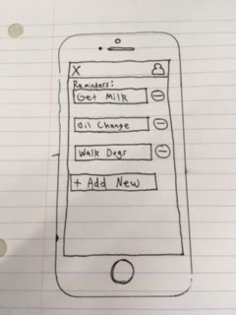

Associates Screen (Preliminary Design)
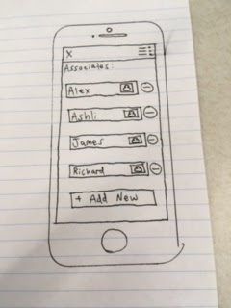

Adding New Reminders (Map Button Not Present) (Preliminary Design)

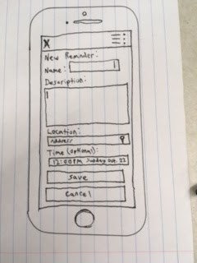

Issues-

- Ethical Issues- (Privacy)
  - One of the major ethical issues that we have identified pertains to the privacy of our users. Our app will essentially obtain the locations of our users, which could be considered as sensitive information. In order for our app to get access to such information, we would, undoubtedly, have to make sure that users freely give our application permission to do so. Our application integrates Google Maps specifically for the purpose of sending location-based reminders for users. When creating events, we will allow users to opt out of specifying the locations on their events if they so choose. We plan to make this apply to events and notes created by other users as well. Lastly, if we expand the social aspect of the application to include public, location-centric groups, then the user would likely not be able to access that portion of the app.
  - Since users are able to create and view reminders set for other people, users may not want certain notes that they have created to be viewable by other people. To solve this issue, we could add a “viewability” setting for each event when it is created. This way, the user can be rest assured that their events will remain private if that is what they wish.

- Intellectual Property Issues-
  - As anticipated from our research, our idea is not the most unique. For instance, Apple has an app, “Reminders,” that allows users to tie a location, time, and/or date to an item if they so choose. One of the differences between that app and ours would be us allowing a list of reminders to be tied to a location, instead of just a single item. We may also elect to include a map-based view of existing events to display for our users. Furthermore, we plan to add a social aspect, meaning we allow users to have “associates” and share their lists with them. We believe that features such as these will help to differentiate our application from existing ones.

Change Log-

- Project Description
  - We have chosen to add the social aspect to our project to better distinguish it from any apps that already exist. We were not planning to do this at the time that we wrote our Initial Project Description.
- Project Milestones
  - Minor updates were made to the milestones to reflect changes to our timeline as well as how our group has discussed approaching the project. More separation of duties may come at a later date.

- Work Plan
  - Due to the addition of the social aspect of our application, we will have to divide those tasks among our group.
- Project Budget
  - This section was updated to reflect our group’s research into integrating Google Maps into an Android application.

